

Homework 6

Particle Swarm Optimization

Advanced Algorithm

Supervisor:

Dr. Ziarati

Atefe Rajabi

40230563

Spring 2024

Index

Introduction

2D Bin Packing

PSO

Literature Review

Proposed Method

Parameters

Implementation Detail

Results

Plots

Discussion

Conclusion

Introduction

The two-dimensional bin packing problem (2D-BPP) is a classic optimization problem where the goal is to pack a set of rectangular items into a finite number of bins, each with fixed dimensions, in a way that minimizes the number of bins used or maximizes the utilization of the available space.

To tackle the 2D-BPP, various heuristic and metaheuristic algorithms have been developed. PSO is a population-based stochastic optimization algorithm inspired by the social behavior of birds flocking or fish schooling. This document presents an implementation of PSO to solve the 2D bin packing problem.

Problem Definition: 2D Bin Packing Problem

The two-dimensional bin packing problem involves packing a set of rectangular items into the minimum number of rectangular bins. Each bin has a fixed width and height, and each item has its own width and height. The objective is to arrange the items within the bins without overlapping, such that the total number of bins used is minimized or the space utilization within the bins is maximized.

Formally, the problem can be defined as follows:

- Given:

- A set of n rectangular items, each with a width w_i and height h_i for i = 1, 2, …, n.

- A finite number of bins, each with a fixed width W and height H.

- Objective:

- Minimize the number of bins used to pack all items, or maximize the utilization of the space within the bins.

Particle Swarm Optimization (PSO) Algorithm

Particle Swarm Optimization (PSO) is a metaheuristic optimization technique inspired by the social behavior patterns of biological populations, such as bird flocking and fish schooling. It was developed by James Kennedy and Russell Eberhart in 1995. The PSO algorithm simulates a swarm of particles, where each particle represents a potential solution to the optimization problem. These particles move through the solution space, influenced by their own experience and the experience of neighboring particles, to find the optimal solution.

1. Particles and Swarm:

- A particle represents a potential solution and has a position and velocity.

- A swarm is a collection of particles.

2. Position and Velocity:

- Each particle's position corresponds to a point in the solution space.

- The velocity determines the direction and speed of the particle's movement.

3. Personal Best and Global Best:

- Each particle keeps track of its personal best position (pBest) encountered so far.

- The global best position (gBest) is the best position found by any particle in the swarm.

4. Update Rules:

- Particles update their velocity and position based on the following equations: 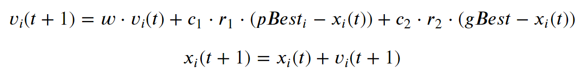

where v_i(t) and x_i(t) are the velocity and position of particle i at time t, w is the inertia weight, c_1 and c_2 are cognitive and social coefficients, and r_1 and r_2 are random numbers between 0 and 1.

Literature Review:

The Island Model Particle Swarm Optimization (Island-PSO) combines the concepts of island models and Particle Swarm Optimization (PSO) to enhance performance in optimization problems like 2D Bin Packing. In Island-PSO, the swarm of particles is divided into several sub-swarms or "islands," which operate independently for a number of generations. Periodically, particles migrate between islands to share information, promoting diversity and preventing premature convergence on local optima.[1]

Particle Swarm Optimization (PSO) leverages the collective behavior of particles moving through a solution space, each particle adjusting its path based on its own experience and that of its neighbors, aiming to find the most optimal solution. When combined with the Genetic Algorithm's (GA) crossover mechanism—where two parent solutions merge to create a new solution inheriting their best features—the hybrid approach enhances the search efficiency. This crossover not only broadens the diversity of the solution pool by introducing variations but also helps in avoiding local optima, a common issue in optimization tasks. Therefore, this integration allows for a more robust exploration and exploitation of the search space, increasing the chances of finding superior solutions more consistently and efficiently in complex problems like the 2D Bin Packing problem.[2]

Proposed Method:

This approach combines Particle Swarm Optimization (PSO) with a 2D bin packing algorithm, incorporating concepts from genetic algorithms and island-based models. It is designed to efficiently address the challenges associated with arranging items into bins while minimizing wasted space, a common issue in logistics and manufacturing contexts.

Particle Swarm Optimization (PSO) Integration

In this method, PSO is applied to explore the solution space of the bin packing problem. The key concept of PSO involves particles, each representing a potential solution to the bin packing problem, moving through the solution space. Their movement is influenced by both their personal best position (pbest) and the global best position (gbest) found by the swarm.

Island Model with Migration

The Island Model enhances the PSO framework by dividing the swarm of particles into several subgroups (islands), each evolving independently. This structure helps maintain diversity within the solution space and reduces the risk of premature convergence on suboptimal solutions. Periodically, selected solutions (particles) migrate between islands, facilitating information sharing and improving the search process across the swarm.

Genetic Recombination

A distinctive feature of this approach is the application of genetic recombination, which involves creating a new particle (child) from three parents: pbest, gbest, and the current particle. This process is regulated by parameters c1, c2, and w, which dictate the probability of selecting features (e.g., bin selections) from each parent. This strategy not only utilizes the strengths of the best solutions found so far but also introduces new variations by combining features from multiple high-quality solutions.

Solution Evaluation and Repair

Once a new child solution is generated through recombination, its feasibility is assessed by checking for duplicate items and ensuring all items are appropriately packed. Any issues, such as duplicates or missing items, are addressed in a repair phase, where adjustments are made to conform to the constraints of the bin packing problem. The positions of items within the bins are inherited from the parent whose features were chosen, maintaining consistency in item placement and potentially reducing the need for extensive rearrangement.

Parameters

1. num_particles: Specifies the number of particles in the swarm. Each particle represents a potential solution to the bin packing problem.

2. max_iteration: Defines the maximum number of iterations the main swarm will perform, allowing the algorithm to converge towards a solution within these bounds.

3. island_iteration: Sets the number of iterations each sub-swarm (island) will execute independently, fostering local exploration before any migration occurs.

4. no_improvement: Indicates the number of consecutive iterations without any improvement in solution quality after which the algorithm might consider termination or a change in strategy.

5. num_islands: Specifies the number of sub-swarms (islands) used in the island model, facilitating parallel exploration of the solution space.

6. migration_interval: Determines the number of iterations between migrations, where selected particles are exchanged between islands to promote diversity and information sharing.

7. w (inertia weight): Controls the influence of a particle's previous velocity on its current velocity, balancing exploration and exploitation in the search space.

8. c1 (cognitive coefficient): Represents the degree to which particles are influenced by their personal best known position, guiding individual particles towards their own best solutions.

9. c2 (social coefficient): Measures the extent to which particles are influenced by the global best position found by any particle in the swarm, steering particles towards the best found solution.

10. max_duration: Specifies the maximum duration (in seconds) the algorithm is allowed to run, providing a time-based stopping condition regardless of other convergence metrics.

11. stop_by_time: A Boolean parameter that, when true, ensures the algorithm stops running when the maximum duration is reached.

Each parameter plays a crucial role in configuring the behavior and effectiveness of the PSO-based algorithm within the context of the bin packing problem, aiming to optimize performance and solution quality within defined computational limits.

Implementation Detail

Particle

The ‘Particle’ class is a core component designed to represent a single solution within the Particle Swarm Optimization framework, specifically tailored for the 2D bin packing problem.

- Initialization: When a ‘Particle’ instance is created, it is initialized with a list of ‘containers’ and ‘rectangles’. The containers represent the arrangement of bins, and the rectangles are the items to be packed. The particle immediately assesses its feasibility, though in the provided description, feasibility is initially set to ‘True’. (since Place Rectangle Module inserts feasibly.)

- Feasibility Check: The ‘check_feasibility’ method evaluates whether the current packing solution adheres to the problem constraints, setting the feasibility attribute accordingly. (The method is not used due to the nature of implementation.)

- Objective Function Calculation: The ‘objective_function’ method calculates the fitness of the particle based on the overall packing efficiency of the bins. It adjusts the objective score to reflect better solutions with higher packing efficiency.

- Position Update with Reinsertion: The ‘update_position_reinsert’ method simulates the particle's movement by randomly selecting an item from a bin and attempting to reinsert it into another bin. This method helps explore the solution space by rearranging items among the bins.

- Position Update by Emptying Bin: The ‘update_position_empty’ method enhances exploration by completely emptying a selected bin and redistributing its contents among other bins. This is a more drastic form of movement within the solution space, potentially finding new configurations.

- Position Update through Communication: The ‘update_position_communication’ method is designed to simulate the communication process within a swarm, where a particle updates its position by considering its own best-known position (‘pbest’), the global best position (‘gbest’), and its current position. This method is critical for integrating collective intelligence into the solution search, allowing particles to benefit from the discoveries and successes of their peers.

1. Integration of Multiple Solutions:

- The method starts by preparing to merge the information from three different sources: the particle's current positions, its personal best position, and the global best position found by any particle in the swarm.

- It aims to create a new set of positions (bins) by considering these three sets of positions.

2. List Management and Weight Application:

- The function manages three lists of bins (from the current positions, ‘pbest’, and ‘gbest’) and dynamically adjusts the iteration across these lists based on their lengths to ensure that bins from each list are considered.

- It applies weights (‘w’, ‘c1’, ‘c2’ parameters) that influence the likelihood of selecting a bin from each of these three sources, effectively controlling the influence of personal and collective memory in the solution search.

3. Selection Process:

- For each index position, the method checks which lists are available and then uses a weighted random choice to decide which list to pick a bin from at that position. This decision is influenced by the provided weights, which can dynamically prioritize personal over global knowledge or vice versa.

- The method ensures that it selects from the available bins without exceeding the list boundaries, making intelligent choices based on the availability and the specified weights.

4. Duplicate and Missed Items Management:

- After forming a new list of bins, the method conducts a thorough check to ensure no items are duplicated across bins and that all required items are included in the solution.

- It creates a mapping of item IDs to track their occurrences and reinserts any missing or duplicated items appropriately to maintain the integrity of the packing solution.

5. Feasibility and Reinsertion of Missed Items:

- The newly formed positions are evaluated for packing feasibility. If any bins are not feasible (either due to overpacking or underutilization), adjustments are made by trying to reinsert items into different bins or creating new bins if necessary.

- The method shuffles bins and attempts to place unallocated items in an effort to find a feasible packing configuration.

The updated positions reflect a blend of individual learning and social learning, incorporating successful strategies from both the particle's own experience and the collective wisdom of the swarm. This process not only helps in escaping local optima but also encourages exploration of new regions in the solution space, potentially leading to better overall solutions.

PSO

The ‘PSO’ class encapsulates the Particle Swarm Optimization algorithm tailored for solving the 2D bin packing problem, leveraging swarm intelligence to find efficient packing solutions.

- Initialization: Initializes a ‘PSO’ instance with a specific number of particles, maximum iterations, improvement criteria, and problem-specific parameters like rectangle dimensions and bin size. Particles can be initialized anew or passed as existing solutions, and the global best solution (‘gbest’) is either given or determined from the initial set of particles.

- Particle Initialization: Particles are initialized using a solution construction method (‘LF_construct_solution’ or an alternative method could also be defined). Each particle represents a potential packing solution and is evaluated for its objective performance immediately upon creation.

- Best and Personal Best Initialization: The algorithm maintains a record of the best solution found (‘gbest’) and the best solution each particle has achieved (‘pbest’), which are critical for guiding the swarm's behavior.

- Running the Algorithm: The main execution method (‘run’) handles the iterative process of updating particles' positions and evaluating their solutions. It includes mechanisms to update the personal best solutions (‘update_pbest’) and the global best solution (‘update_gbest’). The algorithm checks for convergence by monitoring improvements and can terminate early if no improvements are found within a defined threshold.

- Position Update Methods: The particles' positions are updated through methods like ‘update_position_communication’, which simulates the social sharing aspect of PSO. This method enables particles to integrate and test new packing configurations based on their own experience and the successful experiences of others in the swarm.

- Objective Function Calculation: Each particle's packing efficiency is continually assessed through its objective function, which guides the optimization process by quantifying the quality of each solution.

- Construction Solutions: The ‘LF_construct_solution’ and ‘FF_construct_solution’ methods provide different strategies for initially setting up particles. ‘LF_construct_solution’ uses a linear-fill approach, adding items to the first available or new bin, while ‘FF_construct_solution’ employs a more dynamic first-fit approach, where items are placed in the first bin they fit into, potentially reshuffling items among bins to optimize space usage.

- Performance Tracking: The class tracks and stores the best and average objective values across iterations, allowing for analysis of the algorithm's performance over time.

Island PSO

The ‘IslandPSO’ class is an advanced implementation of the Particle Swarm Optimization (PSO) algorithm, structured to solve complex optimization problems like the 2D bin packing problem by dividing the swarm into multiple sub-swarms or islands. This modular approach facilitates parallel processing and enhances diversity, helping avoid premature convergence to local optima.

- Initialization: This method sets up the IslandPSO environment by initializing several parameters such as the number of particles, the number of islands, migration intervals, and other PSO-specific parameters. It creates a more compartmentalized yet collaborative environment where each island operates somewhat independently but contributes to the global solution.

- Migration: The ‘migrate’ function within the ‘IslandPSO’ class plays a pivotal role in the dynamics of the island-based model, where particles periodically exchange information between different sub-swarms or islands. This migration is a key mechanism for maintaining genetic diversity within the population, which can prevent the algorithm from converging prematurely to local optima and can help explore new areas of the solution space.

Topology for Migration:

- The migration function adopts a simple ring topology for the exchange of particles between islands. In this topology, each island acts as a node in a circular chain.

- Each island sends one particle (the one at the end of its list of particles) to the next island in the sequence. Likewise, it receives a particle from the previous island in the sequence.

- The migration occurs simultaneously for all islands, ensuring that each island both sends and receives a particle without any island being left out of the exchange process.

- The function first checks if there is more than one island. If only one island exists, migration does not proceed because there’s no other island to exchange particles with.

- Global Best Update: The ‘update_global_best’ function periodically checks and updates the global best solution across all islands. If a better solution is found on any island, it becomes the new global reference point for all particles across the swarm, guiding the search process towards more promising regions of the solution space.

- Run Algorithm: The ‘run’ function manages the overall execution of the island-based PSO. It initializes individual PSO instances for each island, applies the migration policy, and aggregates results. This function also handles the termination condition based on a maximum number of iterations or a time limit, ensuring that the algorithm stops accordingly.

- Diversity Calculation: Towards the end of the run, or periodically, the ‘calculate_diversity’ function measures the diversity of solutions across the swarm. By analyzing the similarity of solutions (using measures like the normalized mutual information score), this function assesses how varied the particle solutions are, which is essential for understanding the exploration extent of the search space and preventing convergence to non-optimal solutions.

- Performance Tracking: Throughout its run, IslandPSO tracks various metrics such as the average and best objective values per island and globally. These metrics are critical for monitoring the progress and effectiveness of the algorithm in real-time and for post-run analysis.

Results:

Results for 10 times of run

|  |  |  |
| --- | --- | --- |
| instance_name | Min | Max |
| cl_01_020_09.ins2D | 8 | 8 |
| cl_01_040_04.ins2D | 14 | 14 |
| cl_01_060_05.ins2D | 19 | 19 |
| cl_01_080_08.ins2D | 29 | 29 |
| cl_01_100_06.ins2D | 37 | 37 |
| cl_02_020_04.ins2D | 1 | 1 |
| cl_02_040_02.ins2D | 2 | 2 |
| cl_02_060_03.ins2D | 3 | 3 |
| cl_02_080_01.ins2D | 3 | 3 |
| cl_02_100_02.ins2D | 4 | 4 |
| cl_03_020_05.ins2D | 4 | 4 |
| cl_03_040_07.ins2D | 8 | 9 |
| cl_03_060_04.ins2D | 15 | 15 |
| cl_03_080_09.ins2D | 22 | 22 |
| cl_03_100_10.ins2D | 29 | 29 |
| cl_04_020_03.ins2D | 1 | 1 |
| cl_04_040_05.ins2D | 2 | 2 |
| cl_04_060_07.ins2D | 2 | 2 |
| cl_04_080_08.ins2D | 4 | 4 |
| cl_04_100_09.ins2D | 4 | 4 |
| cl_05_020_04.ins2D | 5 | 5 |
| cl_05_040_03.ins2D | 15 | 15 |
| cl_05_060_05.ins2D | 16 | 16 |
| cl_05_080_07.ins2D | 27 | 27 |
| cl_05_100_08.ins2D | 30 | 31 |
| cl_06_020_05.ins2D | 1 | 1 |
| cl_06_040_04.ins2D | 2 | 2 |
| cl_06_060_02.ins2D | 2 | 2 |
| cl_06_080_01.ins2D | 3 | 3 |
| cl_06_100_10.ins2D | 4 | 4 |
| cl_07_020_08.ins2D | 7 | 7 |
| cl_07_040_06.ins2D | 11 | 11 |
| cl_07_060_05.ins2D | 15 | 15 |
| cl_07_080_08.ins2D | 23 | 23 |
| cl_07_100_10.ins2D | 32 | 32 |
| cl_08_020_05.ins2D | 6 | 6 |
| cl_08_040_03.ins2D | 11 | 11 |
| cl_08_060_05.ins2D | 14 | 14 |
| cl_08_080_07.ins2D | 22 | 22 |
| cl_08_100_03.ins2D | 24 | 24 |
| cl_09_020_04.ins2D | 16 | 16 |
| cl_09_040_10.ins2D | 34 | 34 |
| cl_09_060_07.ins2D | 41 | 41 |
| cl_09_080_04.ins2D | 53 | 53 |
| cl_09_100_05.ins2D | 65 | 65 |
| cl_10_020_08.ins2D | 3 | 3 |
| cl_10_040_03.ins2D | 9 | 9 |
| cl_10_060_05.ins2D | 8 | 8 |
| cl_10_080_02.ins2D | 11 | 11 |
| cl_10_100_04.ins2D | 18 | 19 |

Variance and Mean:

The true answer line is based on a greedy algorithm calculation.

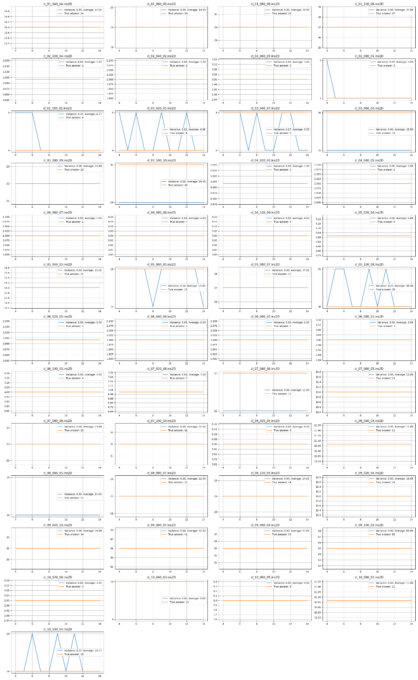

Plots:

cl_1_020_09:

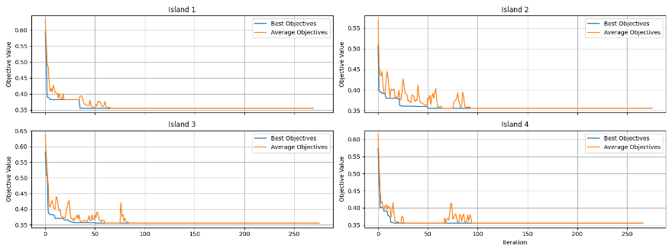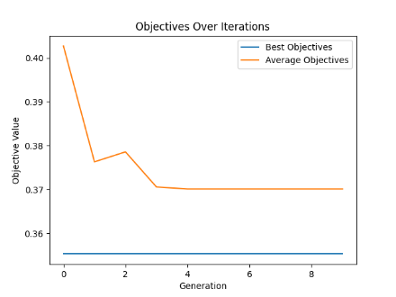

cl_01_040_04:

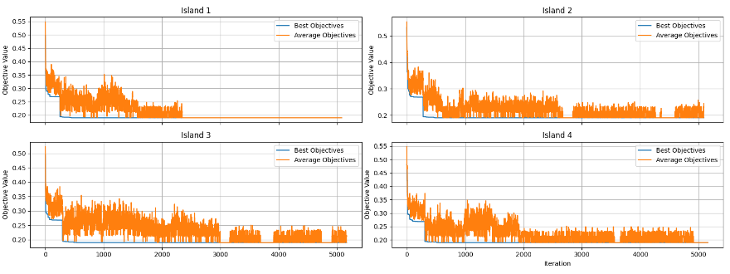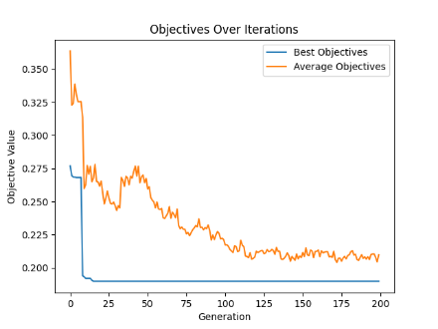

cl_01_060_05:

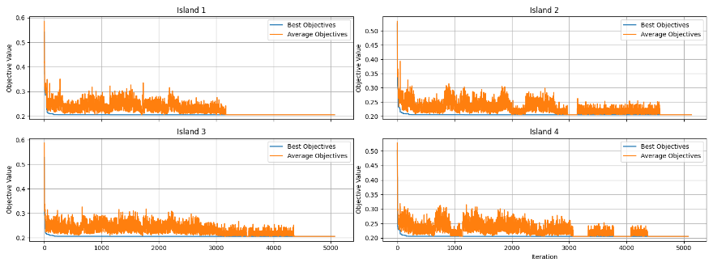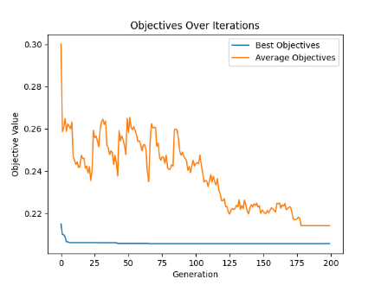

cl_01_080_08:

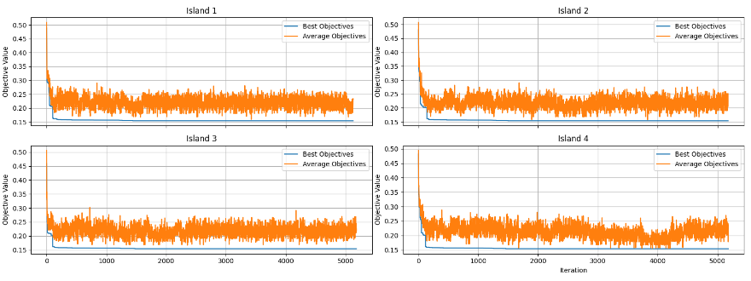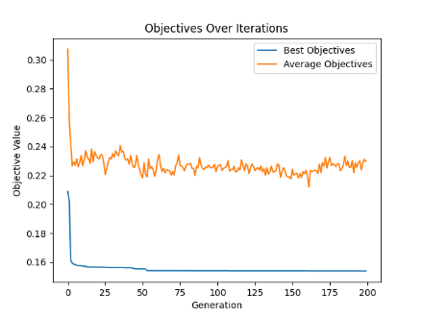

cl_01_100_06:

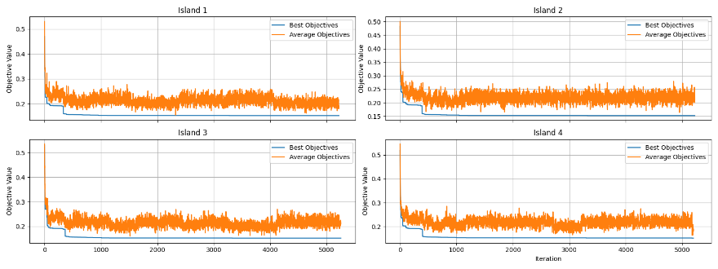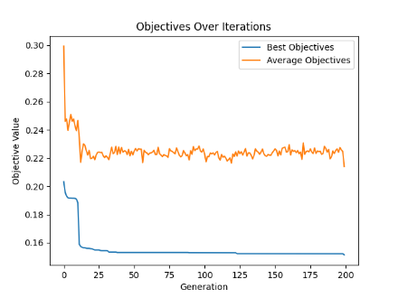

cl_02_020_04:

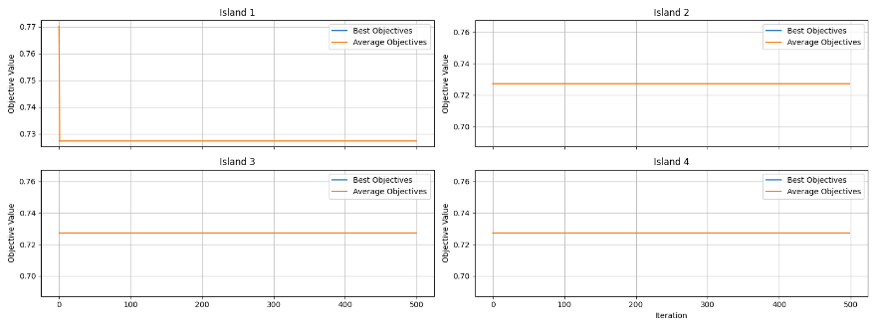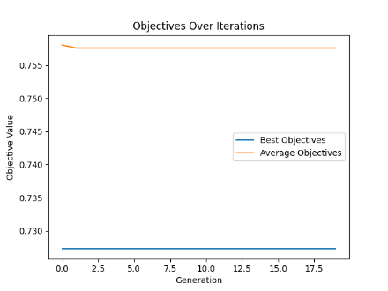

cl_02_040_02:

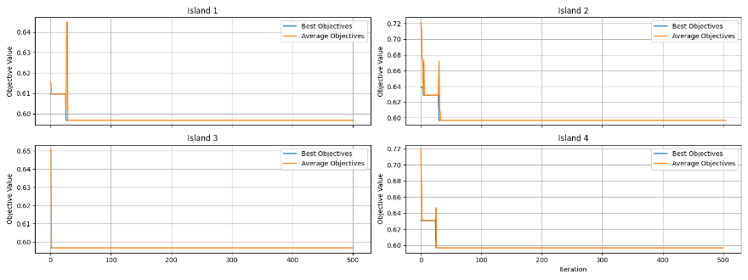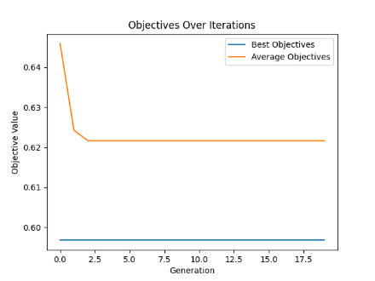

cl_02_060_03:

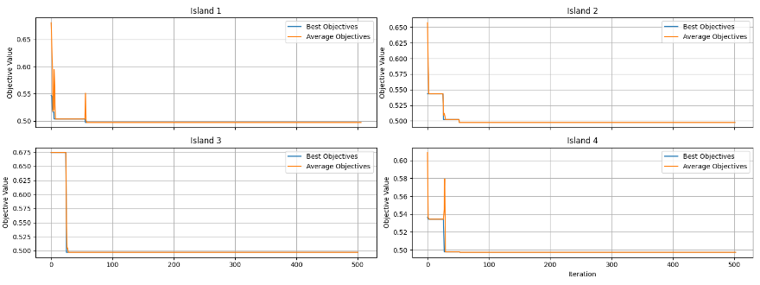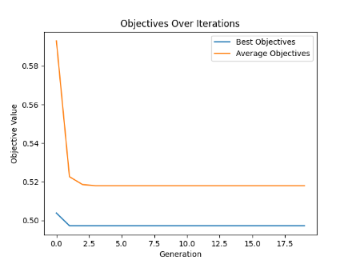

cl_02_080_01:

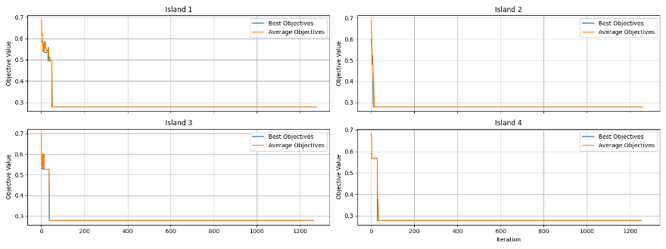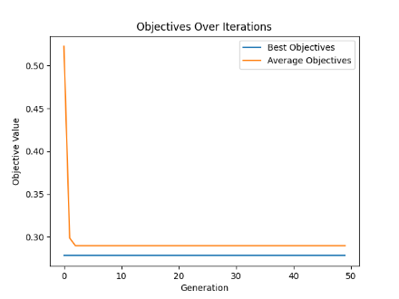

cl_02_100_02:

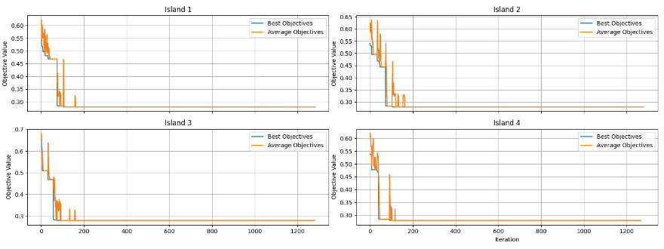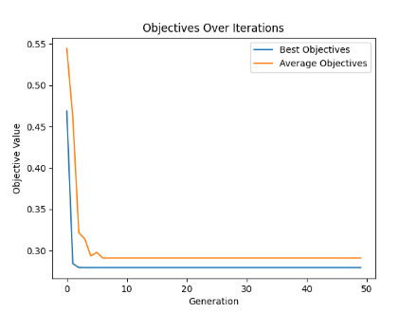

cl_03_020_05:

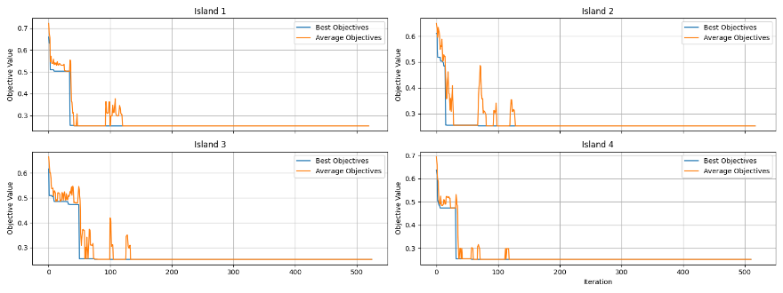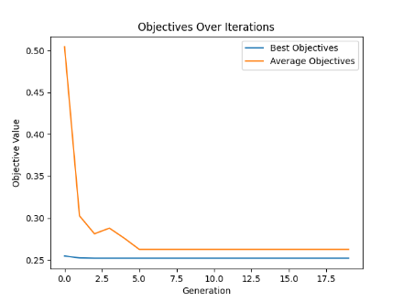

cl_03_040_07:

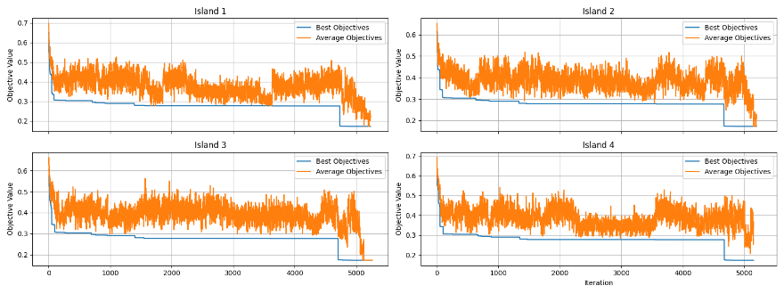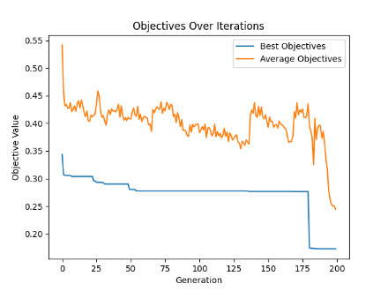

cl_03_060_04:

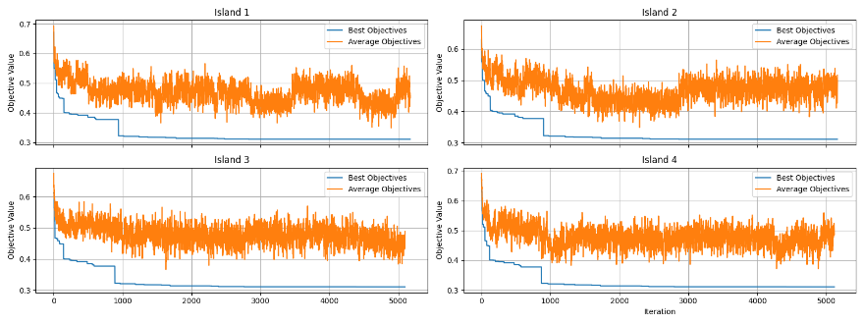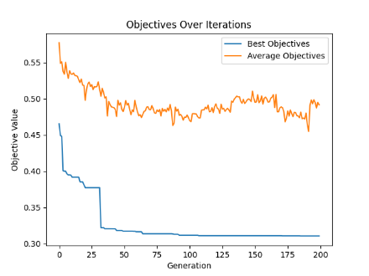

cl_03_080_09:

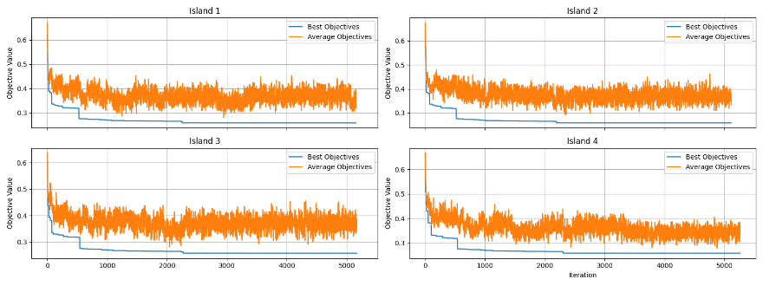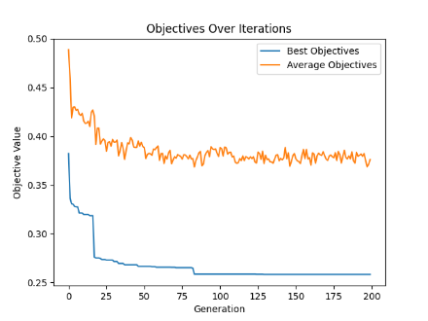

cl_03_100_10:

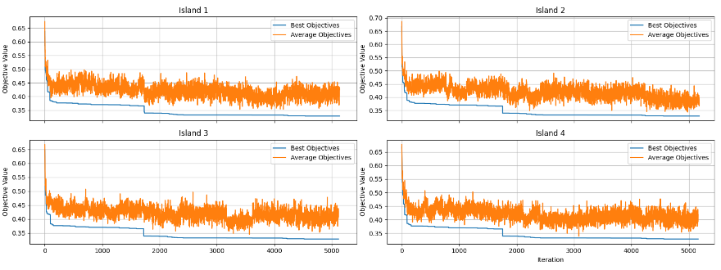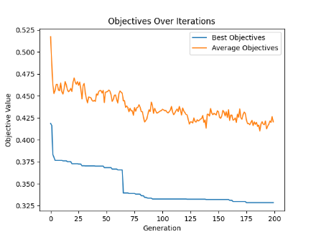

cl_04_020_03:

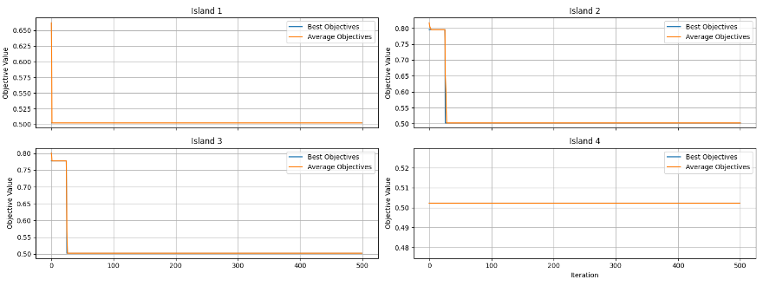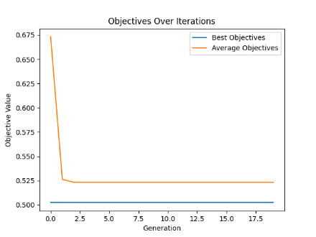

cl_04_040_05:

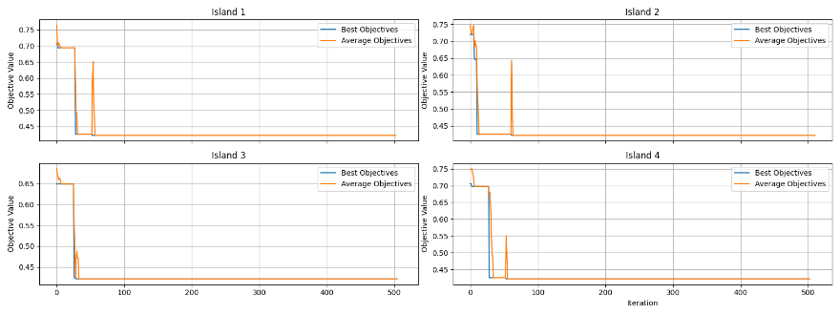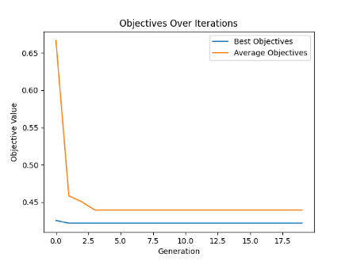

cl_04_060_07:

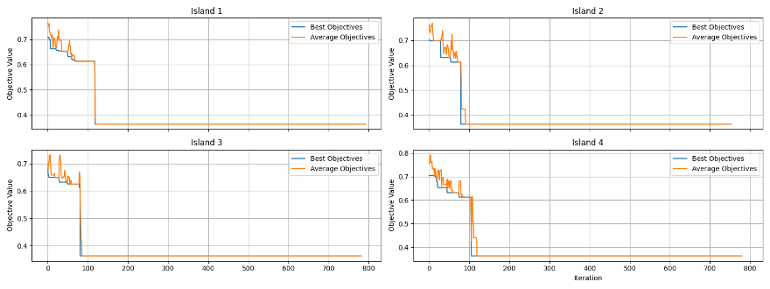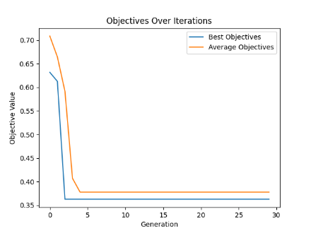

cl_04_080_08:

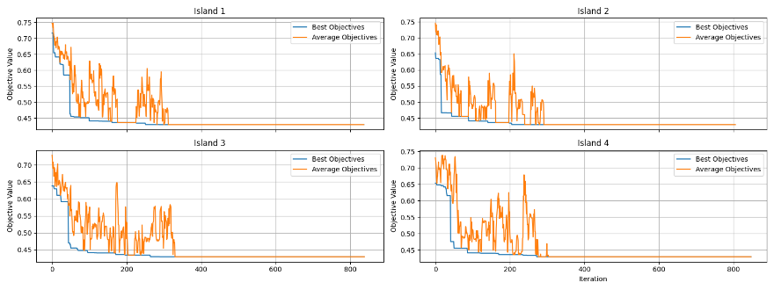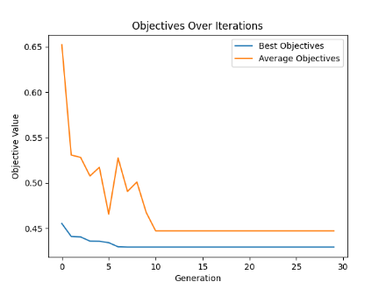

cl_04_100_09:

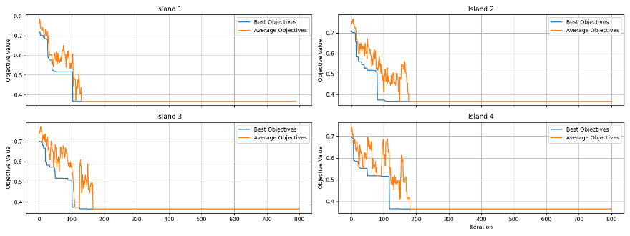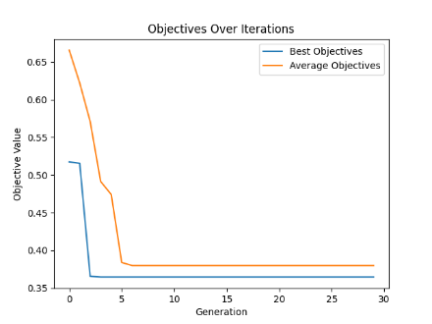

cl_05_020_04:

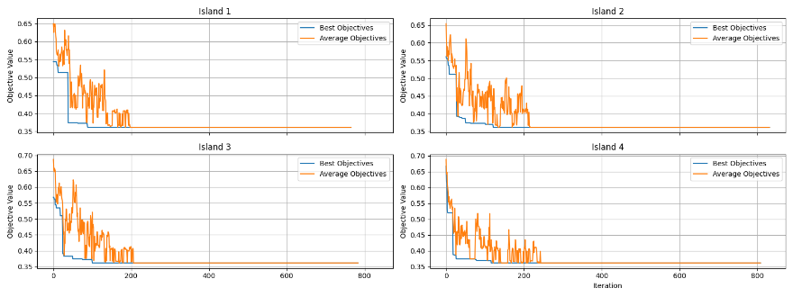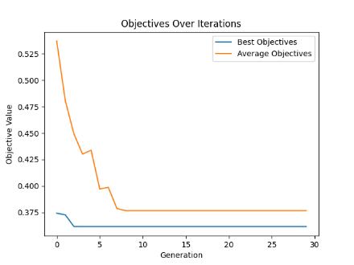

cl_05_040_03:

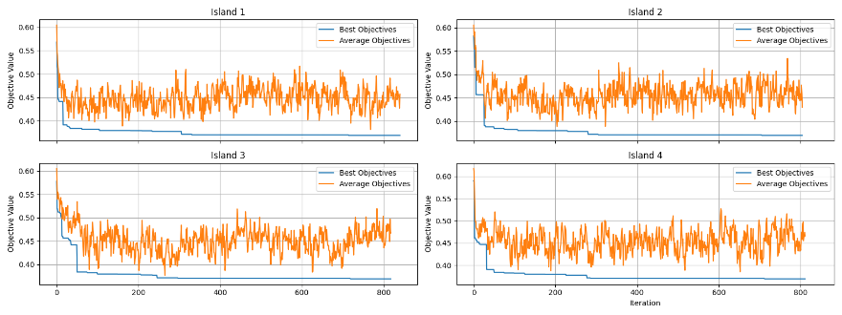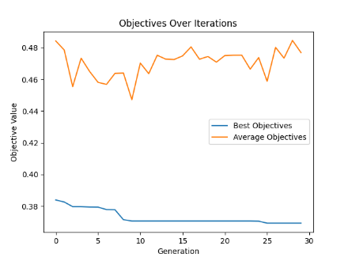

cl_05_060_05:

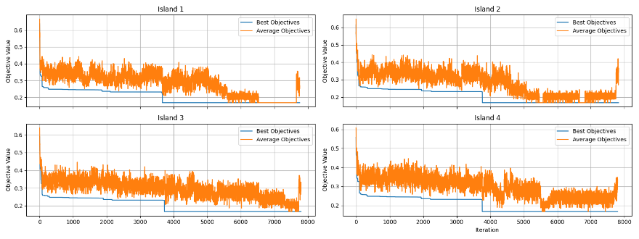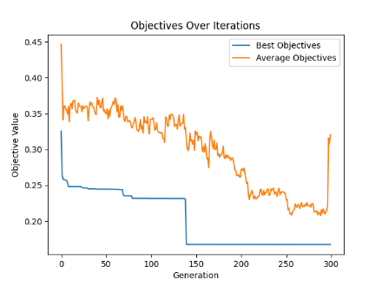

cl_05_080_07:

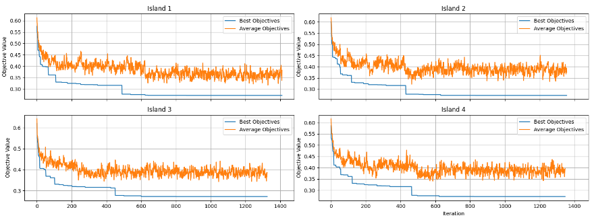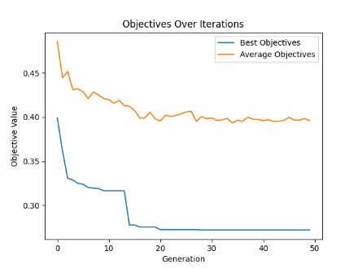

cl_05_100_08:

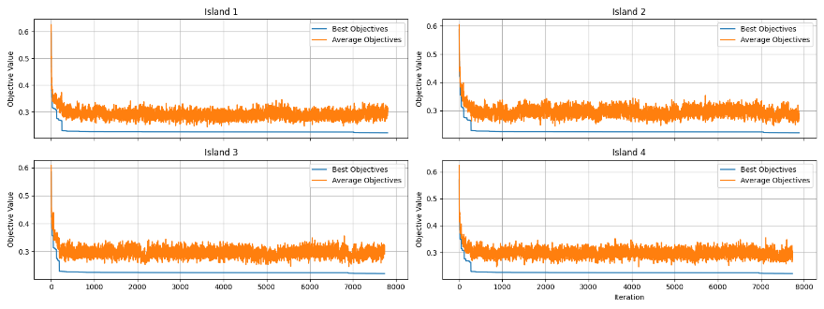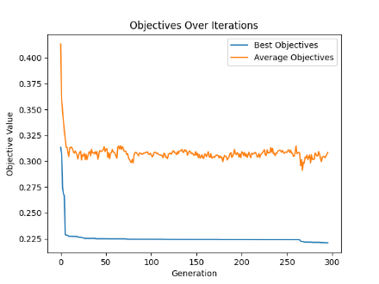

cl_06_020_05:

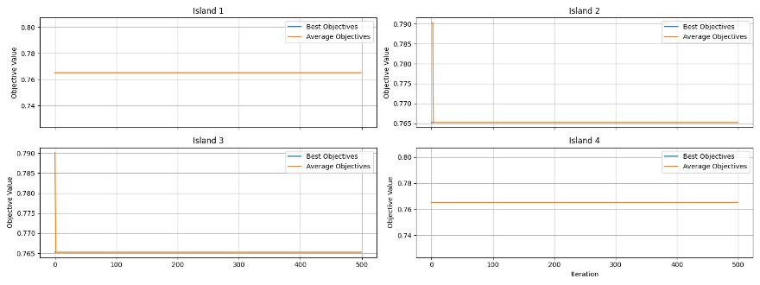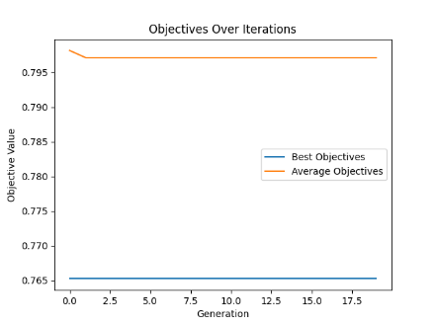

cl_06_040_04:

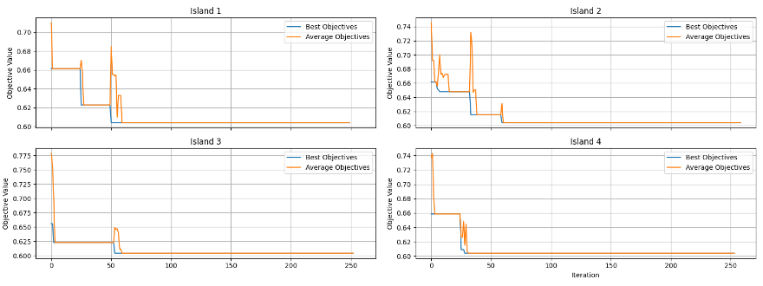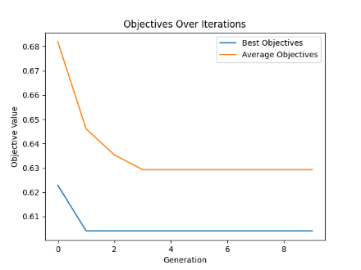

cl_06_060_02:

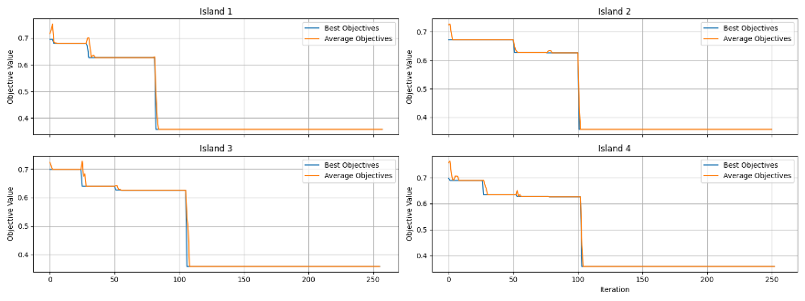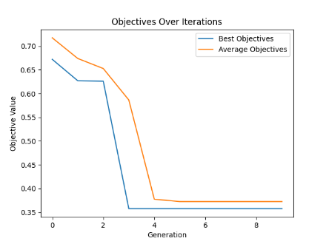

cl_06_080_01:

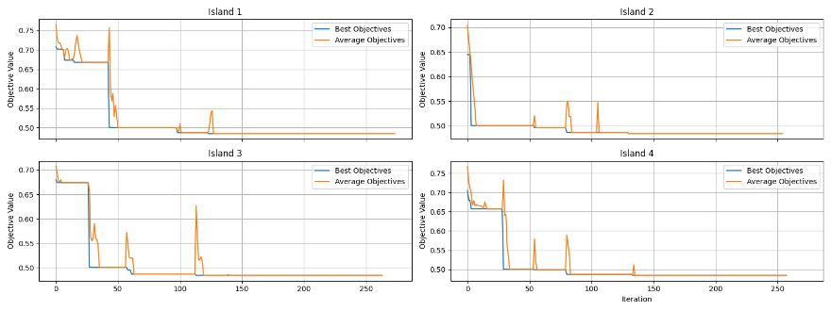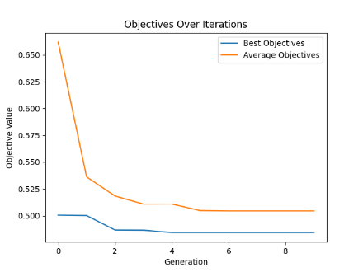

cl_06_100_10:

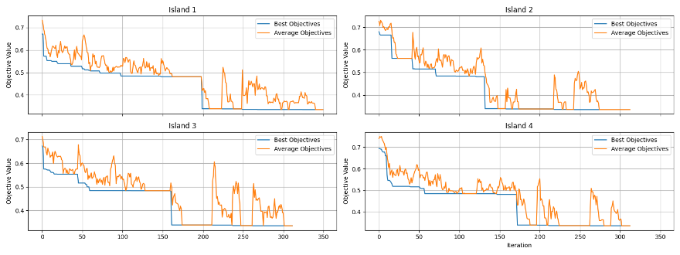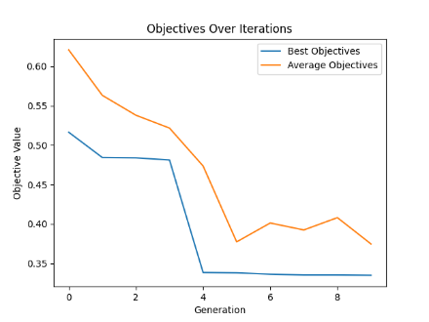

cl_07_020_08:

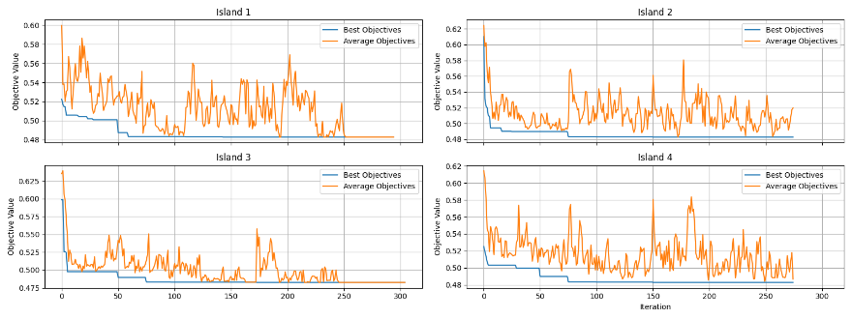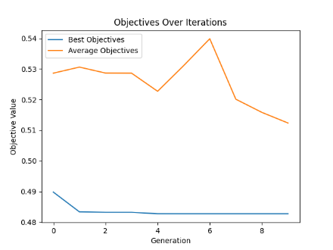

cl_07_040_06:

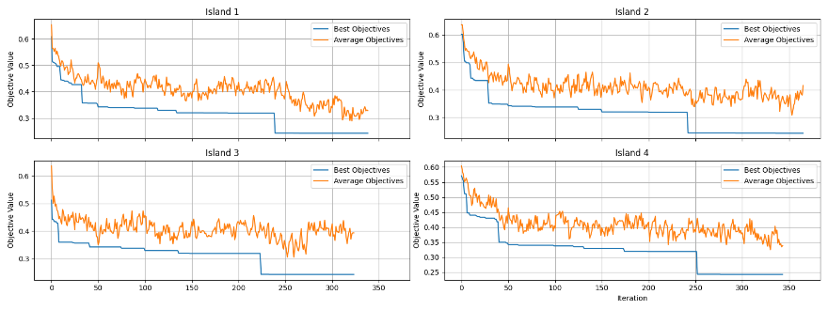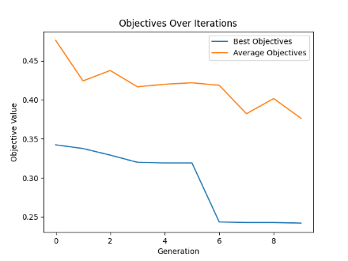

cl_07_060_05:

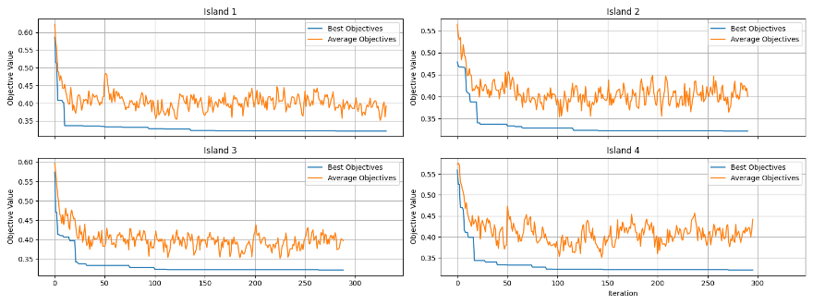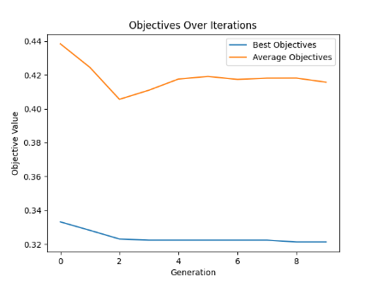

cl_07_080_08:

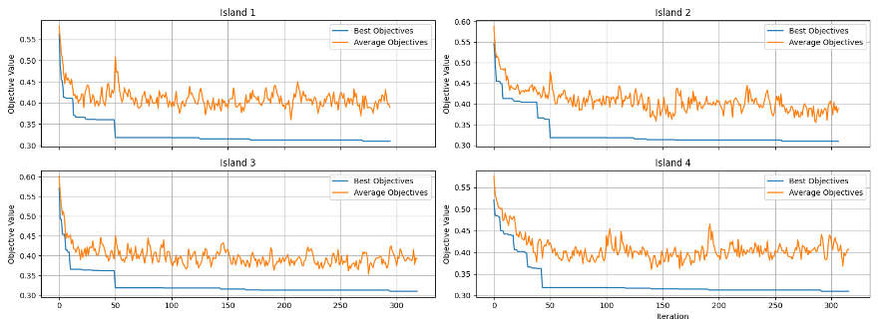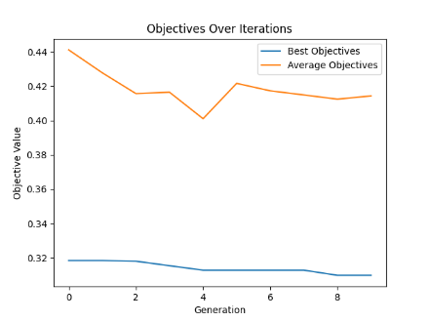

cl_07_100_10:

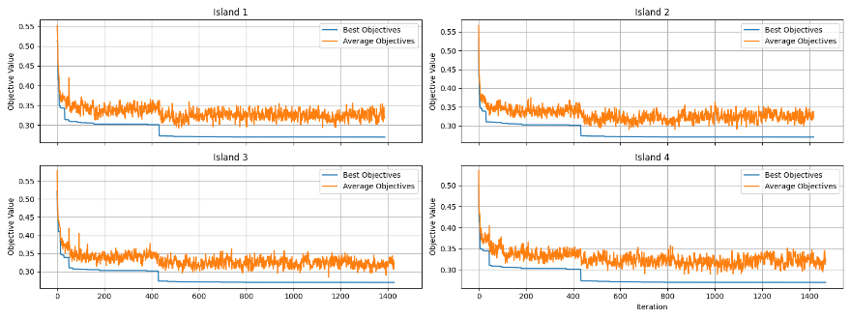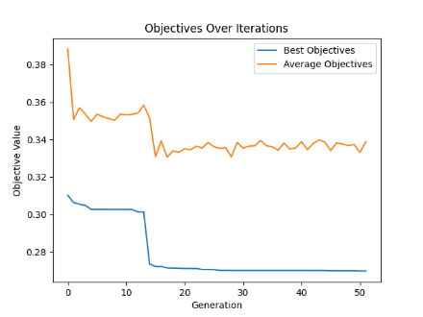

cl_08_020_05:

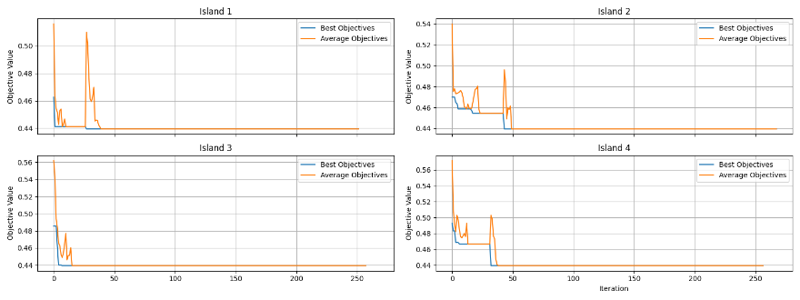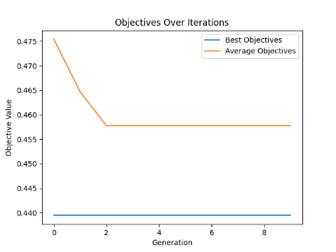

cl_08_040_03:

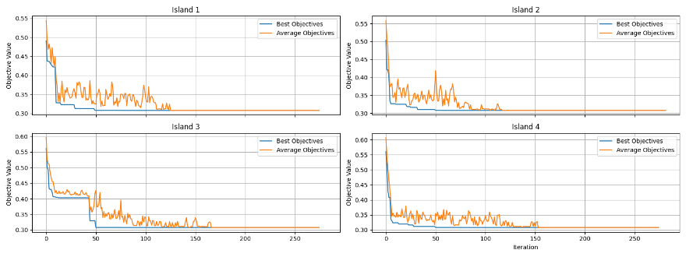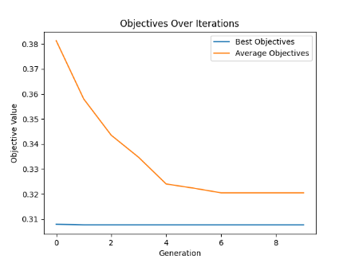

cl_08_060_05:

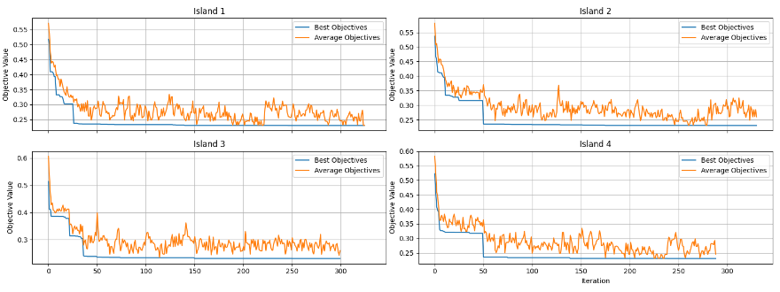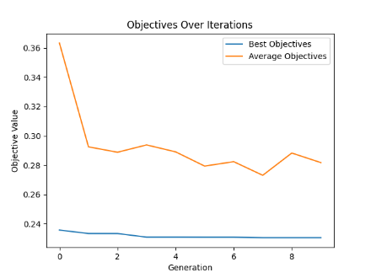

cl_08_080_07:

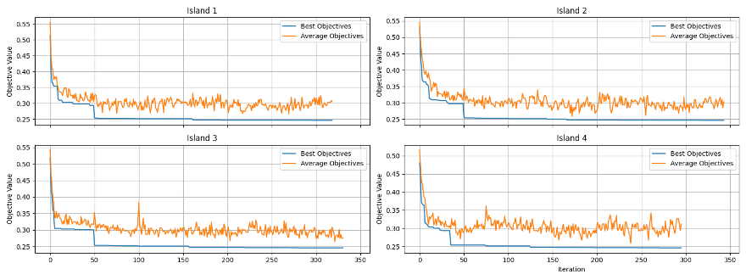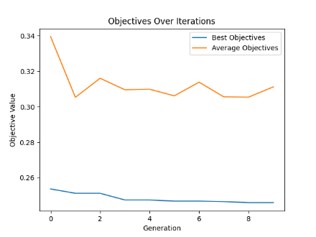

cl_08_100_03:

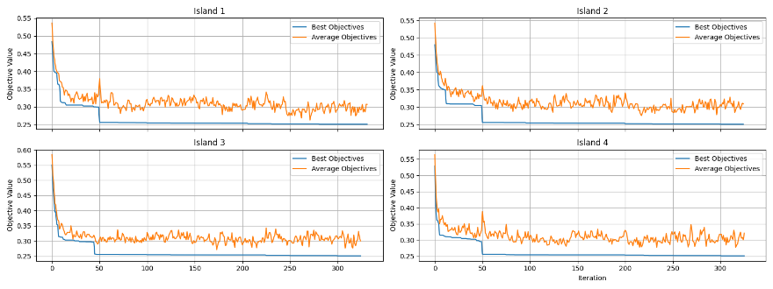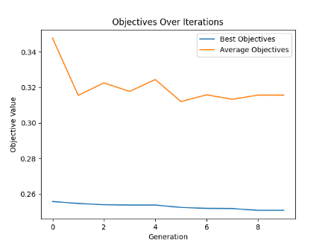

cl_09_020_04:

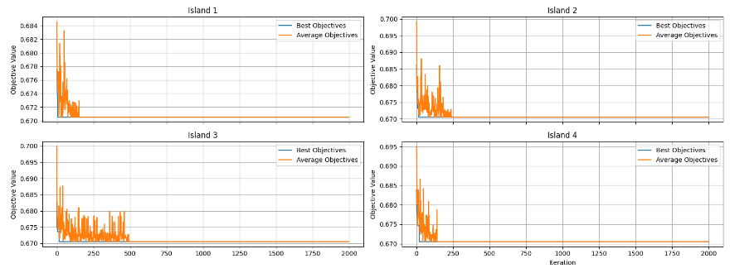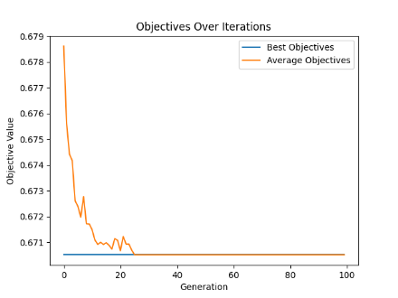

cl_09_040_10:

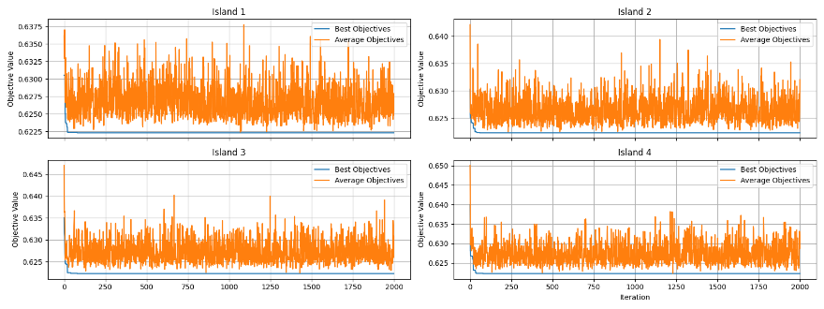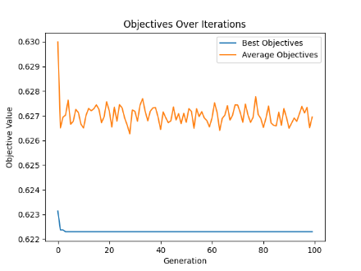

cl_09_060_07:

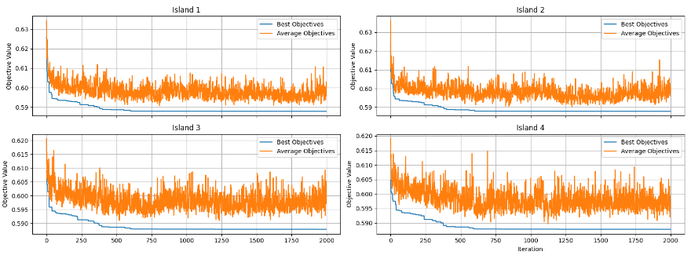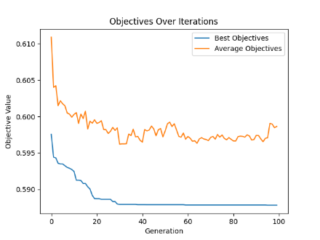

cl_09_080_04:

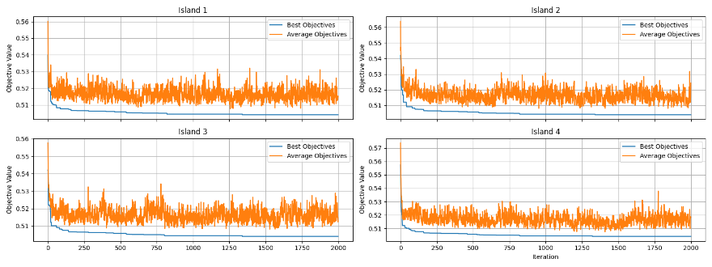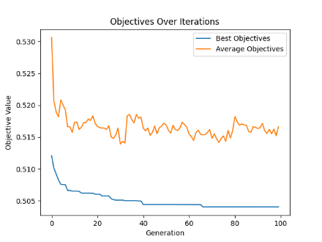

cl_09_100_05:

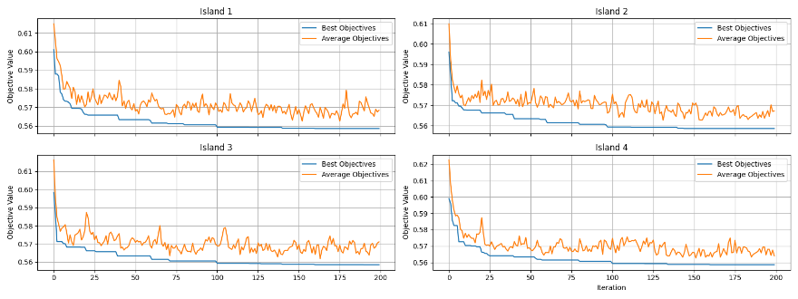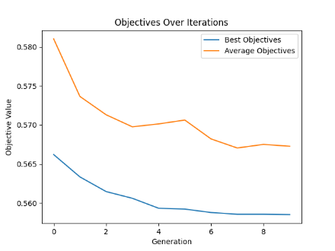

cl_10_020_08:

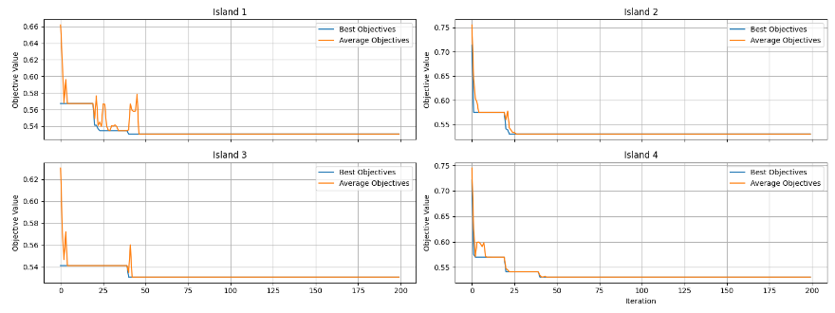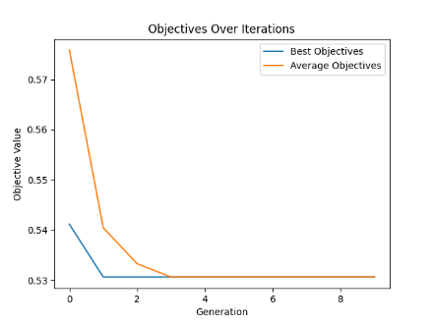

cl_10_040_03:

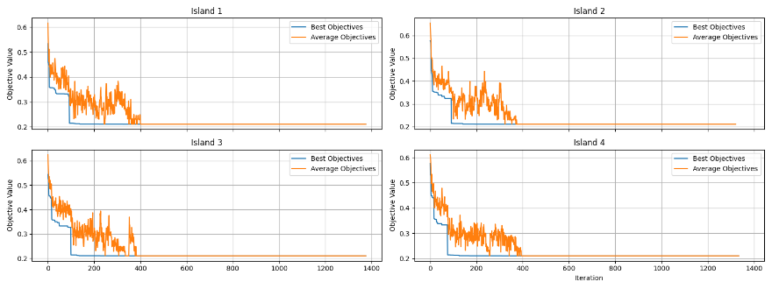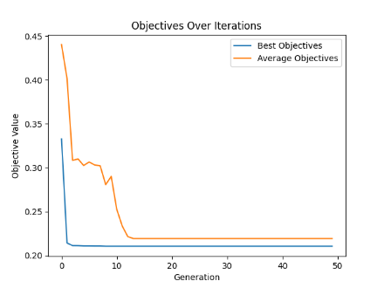

cl_10_060_05:

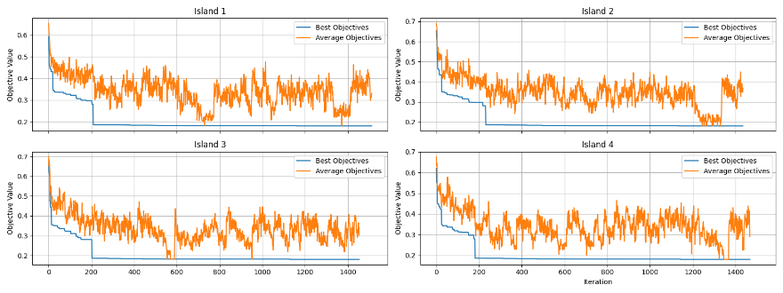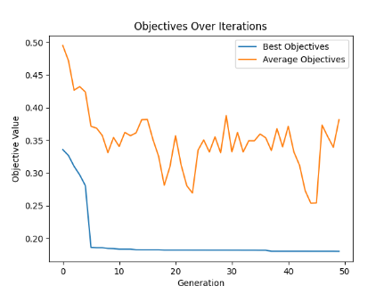

cl_10_080_02:

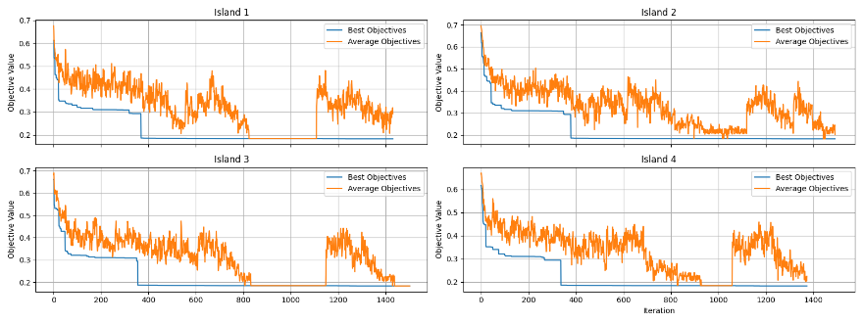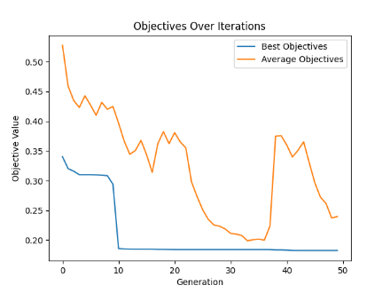

cl_10_100_04:

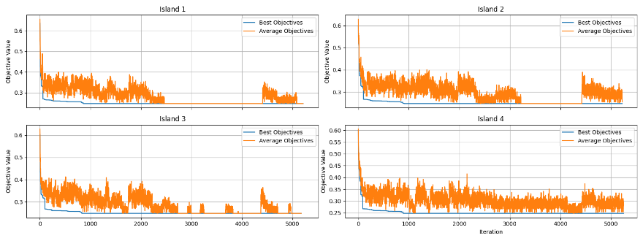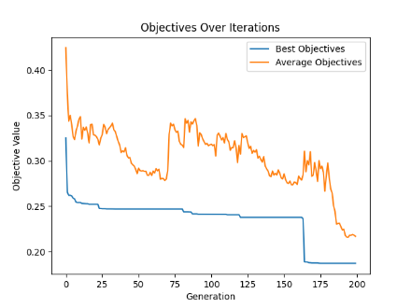

Discussion

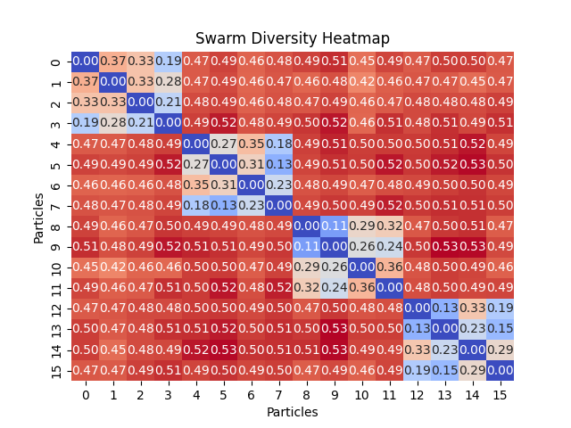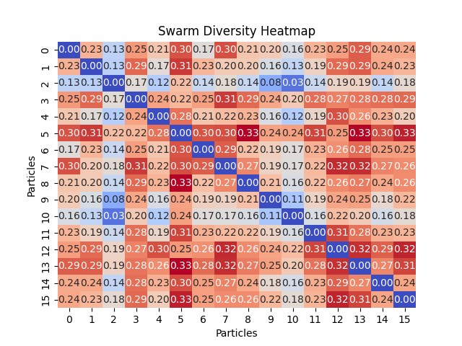Analysis of IslandPSO Performance

Figure

Figure

First Heatmap Analysis (No Migration Scenario)

- Configuration: This scenario involves a setup with no migration between islands, running each sub-swarm for 120 island iterations, with 16 particles divided across 4 islands.

- Observations: The heatmap shows relatively low diversity values within the same sub-swarm compared to between different sub-swarms. This indicates that particles within the same island tend to converge towards similar solutions, reducing their diversity over time due to the lack of external genetic input from other islands.

- Diversity Metrics: The values close to zero within the same sub-swarm reflect this convergence, suggesting that particles are exploring less of the solution space independently and are more influenced by their local bests. The higher diversity scores between particles of different islands underscore the isolation effect—each island evolves independently, exploring different parts of the solution space.

- Outcome: The final result for this configuration is 21 bins, which, while effective, might not represent the optimal solution, given the restricted diversity and lack of cross-island interaction.

Second Heatmap Analysis (With Frequent Migration)

- Configuration: In this setup, the island iterations are reduced to 10, with overall swarm iterations set to 12 and a migration interval of 2. This frequent migration promotes more interaction between islands.

- Observations: The heatmap shows more uniform diversity values across the board, indicating that the migration policy has successfully integrated diverse solutions from different islands into each sub-swarm. This suggests a more balanced exploration and exploitation process across the entire swarm.

- Diversity Metrics: The increased uniformity in diversity scores reflects the effective mixing of genetic material across islands, preventing the sub-swarms from stagnating at local optima. The consistent mid-range diversity scores suggest a healthy level of variation is maintained throughout the run.

- Outcome: The configuration achieves a better packing result with 19 bins, demonstrating the effectiveness of the IslandPSO configuration with frequent migration. This result highlights the advantage of promoting diversity and cross-island learning, which helps in finding more efficient solutions.

Comparing both scenarios clearly illustrates the impact of migration in an IslandPSO setup. Frequent migration not only enhances diversity within the swarm but also leads to better optimization results, as evidenced by the reduction in the number of bins required in the second scenario. This analysis supports the notion that strategic migration intervals are crucial for balancing diversity and convergence in complex optimization tasks like bin packing. By facilitating regular genetic mixing, IslandPSO can effectively escape local optima and explore the solution space more comprehensively, leading to more optimal solutions.

Analysis of Objective Value Trends Across Islands in IslandPSO

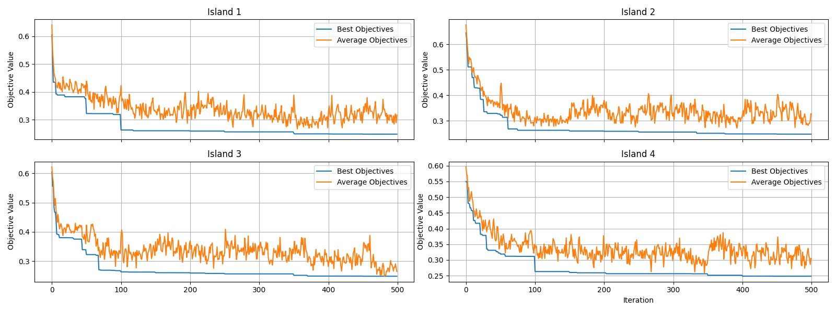

The provided plots display the progression of the best and average objective values for four separate islands over 500 iterations, under a configuration where the island iteration is set to 50 and migration occurs every 10 overall iterations. This data offers insightful trends about the dynamics of the IslandPSO algorithm, particularly in terms of solution improvement and information exchange between islands.

General Observations from the Plots:

1. Initial Sharp Decline: Each island shows a sharp decline in both the best and average objective values at the start of the optimization process. This indicates that initial solutions improve quickly as the algorithm begins exploring the solution space.

2. Impact of Migration at Iteration 100: Notably, at around iteration 100, there is a visible improvement in the best objective values across all islands except Island 2. This suggests that Island 2 discovers a significantly better solution, which, upon being shared through migration, beneficially impacts the global best solutions of the other islands.

3. Stabilization and Minor Fluctuations: Post-iteration 100, while the best objective values stabilize, the average objective values continue to exhibit fluctuations. This is indicative of ongoing exploration within each island, where new solutions are continuously tested against the established bests.

4. Gradual Convergence: Towards the latter part of the plots, particularly after iteration 300, the average and best objective values tend to converge, suggesting that fewer superior solutions are being found and that the islands are beginning to stabilize around certain solutions.

Detailed Insights:

- Island 1 and Island 3: Both islands demonstrate similar patterns with steady declines followed by stabilization. The periodic sharp dips align with the migration intervals, implying effective integration of better solutions from other islands.

- Island 2: This island appears to be a strong performer, especially noticeable around iteration 100 where it influences the other islands significantly. This might be due to Island 2 exploring a particularly fruitful part of the solution space or employing a more effective local optimization strategy.

- Island 4: Shows a more gradual improvement in the best objective values and less volatility in the average objectives compared to other islands, indicating a more consistent approach to exploration and exploitation.

The trends observed suggest that the migration strategy is effectively enhancing the global search efforts by disseminating high-quality solutions across islands, thereby enriching the local searches with new, valuable information. This inter-island communication helps in overcoming local optima and ensures a more robust search of the solution space.

IslandPSO's ability to maintain diversity through migration while steadily improving the quality of solutions highlights its effectiveness for complex optimization problems like bin packing. The periodic migrations not only prevent stagnation but also promote a healthy competition and cooperation dynamic among the islands, leading to overall better performance of the algorithm. This analysis underscores the importance of strategic migration timing and frequency in maximizing the efficiency of distributed evolutionary algorithms.

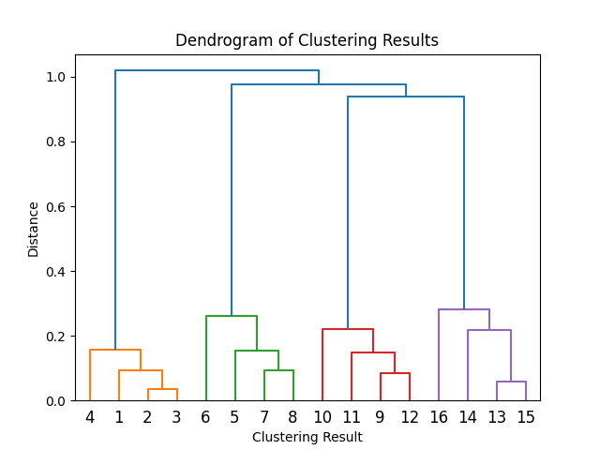Potential Enhancement through Strategic Particle Regrouping Based on Clustering Analysis

The dendrogram of clustering results provides a visual representation of how particles in a swarm are grouped based on their similarities, revealing inherent structures and relationships within the data. This clustering can be instrumental in devising strategies to enhance the exploration capabilities of the swarm, especially during periods of search stagnation.

Concept of Regrouping Particles into Sub-Swarms

The proposed regrouping strategy involves reassigning particles to new sub-swarms based on their positions within distinct clusters identified in the dendrogram. The clusters suggest groupings of particles that share similar characteristics or have converged to similar solutions within the solution space. By regrouping particles across these clusters into new sub-swarms, the strategy aims to inject diversity and foster new interactions and learning dynamics.

Steps Involved in the Regrouping Process:

1. Cluster Identification:

- Analyze the dendrogram to identify distinct clusters of particles. Each cluster represents a grouping of particles that are similar in terms of their search state or position within the solution space.

2. Regrouping Strategy:

- Form new sub-swarms by systematically selecting one particle from each identified cluster, thereby ensuring that each new sub-swarm is composed of particles from every cluster. For instance, if there are four clusters, each new sub-swarm will include one particle from each of the four clusters.

3. Implementation:

- This regrouping can be implemented periodically or triggered when the algorithm experiences prolonged periods without significant improvements, which is an indication of potential stagnation or convergence to suboptimal solutions.

Benefits of the Regrouping Strategy:

- Enhanced Diversity: By mixing particles from different clusters, the regrouping strategy promotes diversity within each sub-swarm. This diversity is crucial for exploring new areas of the solution space that might not be reachable by particles confined to their original clusters.

- Improved Exploration and Exploitation Balance: The new mix of particles will have varied experiences and knowledge of the solution space, potentially leading to better balance between local exploitation of known good areas and global exploration of new areas.

- Prevention of Premature Convergence: Regrouping can help disrupt convergence patterns that lead to premature stagnation, refreshing the search process and giving the algorithm additional opportunities to escape local optima.

- Dynamic Adaptation to Solution Space: This strategy allows the swarm to adapt dynamically to the evolving nature of the solution space across different stages of the optimization process. It ensures that the swarm's ability to respond to complex and shifting problem landscapes is maintained.

Parameters

1. num_particles:

- Exploration: Having more particles increases the capability of the swarm to explore the solution space more broadly, as more diverse solutions can be evaluated simultaneously.

- Exploitation: A larger number of particles also allows for more robust exploitation, as there are more chances to refine solutions based on individual and collective discoveries.

3. island_iteration:

- Exploration: This parameter enables each sub-swarm on an island to explore independently, which can lead to discovering unique solutions that might not emerge in a fully integrated swarm.

- Exploitation: It allows for intense local exploitation within each island, as particles adjust their positions based on local bests without immediate interference from other islands' findings.

5. num_islands:

- Exploration: Multiple islands facilitate exploring different parts of the solution space in parallel, reducing the chances of the entire swarm getting stuck in local optima.

- Exploitation: Each island can independently develop and refine effective strategies, which can be shared across islands through migration.

6. migration_interval:

- Exploration: Setting the interval for migration affects how often new genetic material is introduced into each sub-swarm, helping to prevent convergence traps by bringing in fresh ideas and solutions.

- Exploitation: Regular migration allows islands to exploit new information from other islands, potentially leading to better overall solutions.

7. w (inertia weight):

- Exploration: A higher inertia weight encourages particles to continue exploring in their current direction, helping to cover more of the solution space.

- Exploitation: A lower inertia weight makes particles more responsive to local and global best positions, aiding in fine-tuning solutions.

8. c1 (cognitive coefficient) and c2 (social coefficient):

- Exploration: Higher values of c1 encourage particles to explore based on their own past experiences, promoting diversity in the search.

- Exploitation: Higher values of c2 emphasize collective behavior, steering particles more towards the best solutions found by the swarm, which can accelerate convergence but might risk premature convergence if not balanced with sufficient exploration.

Conclusion

The implementation and adaptation of Particle Swarm Optimization (PSO) techniques, particularly within the context of the 2D bin packing problem, demonstrate significant potential in solving complex optimization challenges efficiently. By harnessing the collective intelligence of particle swarms and subdividing them into islands, we effectively explore and exploit the solution space, yielding promising results while maintaining computational efficiency.

The PSO setup involved strategic configuration of various parameters which directly influenced the algorithm's ability to balance exploration and exploitation—two critical aspects in any optimization algorithm. The number of particles (‘num_particles’) and islands (‘num_islands’), along with the setup of island iterations (‘island_iteration’), migration intervals (‘migration_interval’), and the coefficients of personal and social influence (‘c1’ and ‘c2’), were crucial in managing the swarm behavior.

The algorithm's exploration capabilities were enhanced through the division of the swarm into multiple islands, allowing parallel processing and preventing premature convergence by exploring multiple regions of the solution space simultaneously. Regular migration of particles between islands ensured that successful strategies were quickly disseminated throughout the swarm, enhancing the overall solution quality. This setup also allowed for a dynamic balance between deep local exploration within islands and broader global exploration across the swarm.

Exploitation, on the other hand, was strategically controlled through the inertia weight (‘w’), which dictated the momentum of the particles, and the cognitive (‘c1’) and social (‘c2’) coefficients, which directed the particles towards personal bests and the global best, respectively.

One innovative suggestion that emerged from the analysis was the potential regrouping strategy based on clustering results. By reassigning particles to new sub-swarms according to their similarities and differences as revealed in a dendrogram, which is a method to inject further diversity into the swarm, potentially leading to the discovery of more efficient solutions, especially during periods of stagnation.

Moreover, the periodic assessment of swarm diversity and the adjustment of swarm dynamics in response to observed patterns of convergence and exploration provided valuable insights into how adaptive strategies could be further developed. These strategies are particularly promising for enhancing the algorithm’s robustness and effectiveness in navigating complex and dynamic problem landscapes.

1. Abadlia, H., Smairi, N., & Ghedira, K. (2017). Particle Swarm Optimization based on Island Models. Proceedings of the Genetic and Evolutionary Computation Conference Companion (GECCO'17), Berlin, Germany. doi:10.1145/3067695.3076068.
2. Borna, K., & Khezri, R. (2015). A combination of genetic algorithm and particle swarm optimization method for solving traveling salesman problem. Cogent Mathematics, 2(1), 1048581.

   [doi: 10.1080/23311835.2015.1048581](https://doi.org/10.1080/23311835.2015.1048581)